Course Specialist Test 4 Year 12

Student name: ________________ Teacher name: ________________

Task type: Response

Time allowed for this task: ____40_______ mins

Number of questions: _____7______

Materials required: Calculator with CAS capability (to be provided by the student)

Standard items: Pens (blue/black preferred), pencils (including coloured), sharpener, correction fluid/tape, eraser, ruler, highlighters

Special items: Drawing instruments, templates, notes on one unfolded sheet of
A4 paper, and up to three calculators approved for use in the WACE examinations

Marks available: _44_____ marks

Task weighting: _10___%

Formula sheet provided: Yes

Note: All part questions worth more than 2 marks require working to obtain full marks.

Q1 (3 & 3 = 6 marks)
Solve the following.
- given that when .

- given that when .

Q2 (4 marks)
An iron has a temperature of is left in a room, of temperature , to cool such that the temperature at time minutes is given by . After 15 mins the temperature of the iron is . Determine the time taken for the iron’s temperature to drop to .

Q3 (1, 5 & 2 = 8 marks)
The number thousands, of bacteria cells living in a petri dish at time hours is given by .
The initial number of cells was 2 thousand.
- What is the limiting value of the number of cells as ?

- Using calculus and partial fractions, show every step to express in terms of .

Q3-cont

- Determine the number of cells after 15 hours.

Q4 (3, 2 & 2 = 7 marks)
Consider the slope field
- Sketch this field on the axes below.

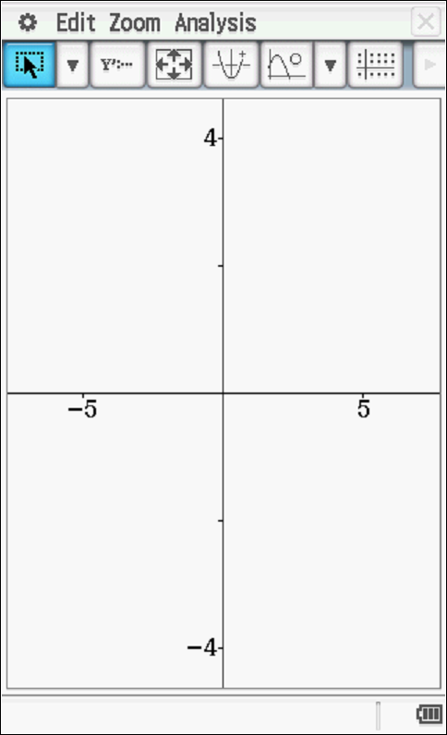

- Draw the solution curve, axes above, that contains the point (1,1).

- Determine the equation of the solution curve that contains (1,1).

Q5 (2, 2 & 3 = 7 marks)
Consider an object that is moving with Simple Harmonic Motion such that with in metres and seconds respectively. At , metres and is a rest.
- Determine a rule for in terms of .

- Determine the exact speed when metres.

- Determine the percentage of the time, to one decimal place, that the object is less than 3 metres from the mean position, .

Q6 (4 marks)
Consider an object that is initially at the origin and at rest such that its acceleration is given by where equals the speed in at seconds . Determine the exact speed when its displacement from the origin is metres.

Q7 (2, 3 & 3 = 8 marks)
A lolly company makes jelly beans where the mass of one jelly bean is normally distributed with a mean of 23.4 mg and a standard deviation of 3.2 mg. (Note: 1g=1000mg)
- Determine the probability to two decimal places that the total mass of 85 jelly beans is more than two grams.

- Given that the probability that the mean mass of a jelly bean differs from the population mean by more than 0.35 mg is 5%, determine , the number of jelly beans that need to be sampled.

- On a particular day the operator of a machine that makes jelly beans is suspected of being faulty. A sample of 200 jelly beans had a sample standard deviation of 3.8 mg with a total mass of 5.4 grams. Present a mathematical argument to either support or to dismiss such a claim.

